

5/12/2017

Final Year Project 2017

**Your Office Planner**

A dissertation presented for the degree of BSc. (Hons) Software Engineering.

Student ID

School of Computing, Engineering and Mathematics

University of Brighton

Table of Contents

Project Scope 3

1.1 Aims and Objectives 3

1.2 Stakeholders 3

1.3 Methods of Communication 3

1.4 Research 3

1.4.1 Which language to use ? 3

1.4.2 Which Database to use ? 4

1.4.3 Which Encryption to use ? 4

Specification 5

2.1 Deliverables 5

Figure 2.1 6

2.2 Analysis 6

2.3 Risk Analysis 7

2.4 Quality Analysis 8

3.1 Methodology 8

Development 10

4.1 Architecture 10

Testing 10

5.1 Automated Testing 10

5.2 Manual Testing 10

5.3 Stress Testing 10

Deployment 10

Review & Reflection 10

7.1 Background Research 10

7.2 Specification 10

7.3 Methodology 10

7.4 Limitations & Improvements of the application 10

7.5 Conclusion 10

References 11

# 

# Project Scope

## Aims and Objectives

The ultimate objective of “Your Office Planner” project is to provide a Room Booking software for World of Books employees. The main aim for this project is to allow employees to create meetings at chosen time and selected room. Employee will be able to store the notes in the program and retrieve them.

## Stakeholders

The Stakeholders involved in this project will be World of Books, myself and supervisor and the second reader. World of Books will be the main stake holder as they will be the main users using this software and testing. Stake holders will be giving the requirements for this project.

## Methods of Communication

Communication with the main stakeholder was twice a week at the World of Books company. Where I’ve been showing the progress on the project to IT Manager and IT Infrastructure manager. Who gave their opinion about the software and changes that should be made to the project.

## Research

I have made a research on three very important parts of my project which are Programming languages, databases and the encryption methods. The programming language maybe is not as important as the other two however still had to check which programming language to use for this project.

## Which language to use?

When it comes to application development there are many programming languages which are relevant to writing such application. Each programming language will fill different role and will have advantages, disadvantages and is different in its own right.

**Java**

Java is one of the best programming languages created. Java is an Object Orientated Language which has a lot of Open Source libraries, great collection of powerful IDEs and has a rich API. Java offers swing for GUI creation which would allow me to create everything for the project. This is why Java is great for GUI creation which my software will use a lot. Following the research, I have found out that there is not a lot of desktop java jobs, there are many more server side jobs however java can be enough to use for a desktop java application if it can meet all of the requirements. Java doesn’t have a framework for Java desktop application which is definitely a disadvantage however it can still produce a good desktop application. Definitely Java is the easiest language to write desktop apps and it is great if you want the software to be compatible with all the platforms.

**C++**

I have chosen to research C++ as my second language as I have previous experience in using this language. C++ is a multipurpose language. C++ has a disadvantage which it’s not good if you want your desktop application to be compatible with all of the platforms. This is why the C++ is not good for this project as “Your Office Planner” will be working on Windows, Mac and Linux.

## Which Database to use?

**SQL vs Postgres**

When it comes to applications development where there is sensitive data and a lot of database usage it is very important to choose a right database. The database will hold mostly very confidential information which should not be lost or hacked. The database will continuously create, update and remove data, it will also have encrypted information which will be decrypted and encrypted. MySQL and Postgres are very similar DBMS however there are features and functions that are different and both have their pros and cons.

PostgreSQL has a lot of very useful feature as generate_series, custom aggregate functions, arrays and many more which make life a lot easier. However, MySQL has a lot of features that Postgres doesn’t have. The main difference but very significant is that MySQL has only one Server operating system which is windows where Postgres has Windows, OS X, Linux and many more it has much broader reach because of that. Postgres is an open source where MySQL is a commercial software. The disadvantage of Postgres definitely has to be that is behind MySQL on the popularity level , what comes with that(See figure 1.4.2) ? It makes it a lot harder to get community support or google the results that you are looking for .

Figure 1.4.2:

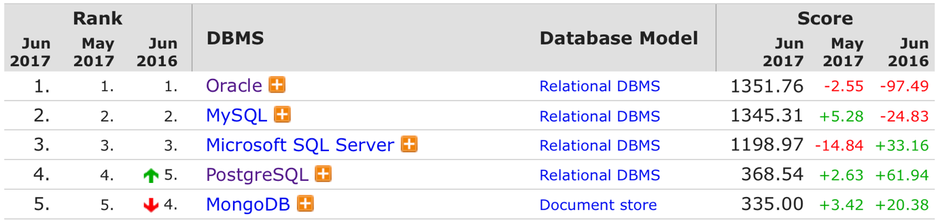

Both of the databases have a very good tooling as (MySQL Workbench vs PostgreSQL pgAdmin 3) , have been proven to be mature in production and have companies behind them if you need a professional support(Oracle and Percona vs EnterpriseDB). In terms of performance between the two PostgreSQL is used mostly in large systems where read and write speed is very important and the data has to be validated. MySQL is mostly chosen for the web based applications that need a database for easy and simple data transactions. MySQL usually underperforms when there is heavy loads or running very complex queries.

There is a comparison between MySQL and PostgreSQL which show the time difference in file selection between these two DBMS. (See figure 1.4.3)

Figure 1.4.3:

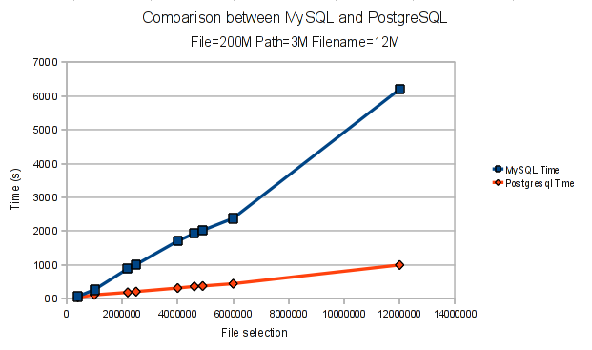

The graph clearly shows the difference between PostgreSQL and MySQL and that the first one is much faster at selecting files. However this would have to be a very big database to see the real time difference between the two. In a smaller queries it doesn’t real make this much of a difference.

PostgreSQL has ROLES and inherited roles to set and maintain permissions. PostgreSQL has native SSL support for connections to encrypt client/server communications. It also has Row Level Security

MySQL implements security based on Access Control Lists (ACLs) for all connections, queries, and other operations that a user may attempt to perform. There is also some support for SSL-encrypted connections between MySQL clients and servers.

## 1.4.3 Which Encryption to use?

**AES vs Triple DES**

## Current solution to the problem.

The current solution for the problem right now is using google spread sheets where the room is booked for a certain time and can be accessed from any computer and changeable by anyone in the company who has access to the link. This problem still exists as not everyone is checking the link. The people are invited by writing a personal email to each person explaining the meeting agenda. The notes are being stored on the paper or personal laptop . The first is very unsecure as anyone can get hold of the notes as well as it is very easy to loose piece of paper with confidential information. The second option is more secure however still anyone can access the clients computer and get hold of the notes, also it is very easy to delete the document or very time consuming to find the exact notes inside the folder with many files . There are solutions as buying a software which would the company would have to pay for either annually or monthly. This is a good solution for a big company however much safer option is having a unique software with data kept on the internal server at the company premises.

# 

# Specification

# 2.1 Deliverables

The first intermediate product will be creating Database using Postgres. This will contain all the users information, created events, users invitations and encrypted notes. The database will later be stored on the server inside the company premises. This development will be overlapped with the development of the admin side of application and the Gregorian Calendar in java. This will allow to add admin to the application who will be able to manage users data. The first end deliverable will be the users side of the application. This will be broken down into several intermediate products, creating new events, editing events, creating notes/reading notes, inviting/removing users from event. After three of these deliverables will be finished, I will provide dummy data for the user testing. After the software has been user testes I will receive the feedback from the co-workers and managers from World of Books who will give their opinions about the product and the changes that have to be done before the final delivery of the software.

The second end deliverable will be the final report containing documentation and screenshots of the applications explaining how the application works and the chosen ways of delivering this

software.

The initial estimated schedule of activities to produce these deliverables can be seen in figure 2.1.

## Figure 2.1

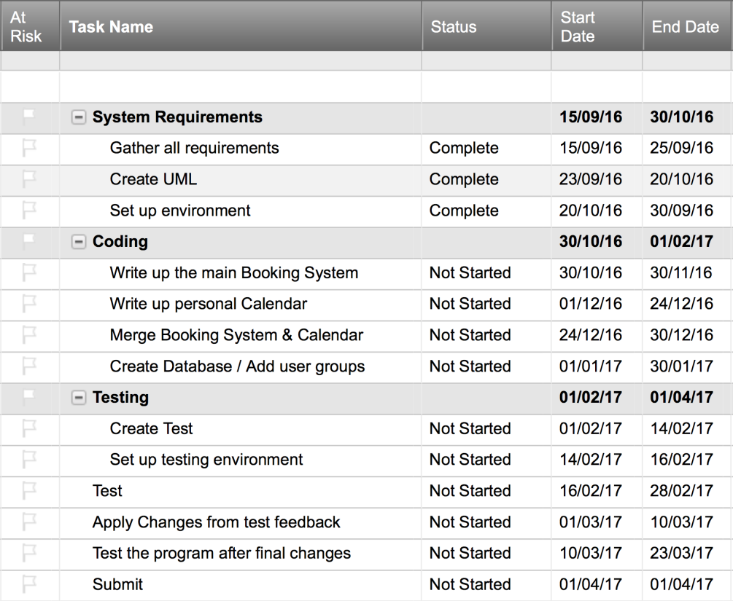

## 

# 2.2 Analysis

## 2.2.1 Why Room booking system?

The first major point of analysis is why I have decided to create a Room Booking System & Personal Calendar rather than anything else, maybe more original. The main reason is I am working at the second biggest seller of used books in the world which doesn’t have such software in place. This causes a lot of problems around the company. This made me think that I could do two things at once which are my final year project for university as well as creating a software which will resolve the issues in the company. My ambition is to get into a software development company where I could create more applications like this one and this application will be something that I can show to people and be proud of.

## 2.2.2 Programming Language

I have chosen Java for this project as I have been working with this language for the past three years. Java has all the features that are crucial for this software also I have had working experience with java at placement. I have used Java for many projects over the years and it makes me feel comfortable using it and visualise how the project would be written in this programming language. The other option was the C++ which is very similar to Java however I have had less experience using this language and it would make it much harder if approached problems.

The other dilemma I had to make a decision for was if to make a Java web application or desktop application this was the matter of experience, I’ve had much more experience in building desktop applications than web applications. Another impact on creating a desktop application was that I wanted to develop an offline version for the software where the user can access their calendar and notes when they are offline in case the server or internet goes down at the company.

## 2.2.3 Why Postgres?

I have chosen Postgres database for the same reason I have chosen Java, this is because I have had a lot of experience writing Postgres functions at the placement. The company is mainly using Postgres database and it is the software that is placed on the company server. The Infrastructure manager at the company has advised me to use this database for the project as the software is already in place on the server and it could cause problems as the two databases would be fighting for the same resources (I/O, CPU and Network), which could become a bigger problem for ecommerce company which is based on the performance.

## 

## 2.3 Quality Analysis

The main measure of success will be when all their requirements will be met and all software functionalities will be working. I will have to make sure all of the functionalities are tested to the finest and assures the quality of the project.

## 2.4 Risk Analysis

|  |  |  |  |  |
| --- | --- | --- | --- | --- |
| Risk | Probability (1-5) | Impact (1-5) | Mitigation | Contingency |
| Illness/Injury | 4 | 3 | -Reserve time for illness  -Be hygienic  -Eat healthy  -Exercise | - Allow time for recovery  - Take medicine to aid recovery |
| Inaccurate estimations | 3 | 3 | -Be liberal with estimations  -Reserve tune fir deliverables behind schedule | -Adjust scope of project |
| Data loss | 1 | 5 | -User a version control system  -Keep local backups | - Recover data from git |
| Uncommunicative stakeholder | 1 | 3 | -Ensure regular meetings with stakeholder |  |
| Stakeholder turnover | 1 | 4 |  | -Get new stakeholders |
| Project scope too large | 3 | 4 | -Research enough to be certain in project scope  -Be liberal with estimations | -Adjust scope of project |
| Technologies to immature/ insufficient for project | 2 | 4 | -Research technologies beforehand | -Find alternative technologies Adjust scope of project |

# 

# **3.1 Methodology**

I have chosen the agile development methodology for this project as it has suited me and the clients, also I have had previous experience working with this methodology. Working with agile allows me to pick tasks from the backlog one at the time and progress through the cycle. At this project, it was very convenient as I would meet with the clients at World of Books twice a week where they would review the code and give me feedback for the completed tasks.

1. To Do
2. In Progress
3. Test
4. Review
5. Feedback
6. Done

­­­

In the “To do” step of workflow are all the things that have to be done. From this section I will choose tasks one by one or maximum of two at the time. In the “In Progress” stage the code will be written to meet the requirements defined at the beginning of the project. After the code is completed than the Test writing begins, the test will check if all the functionalities of the code are working. This part is very important as it saves a lot of time in development as the errors can be found at the early stages of implementation rather than testing large chunks of code further in development or at the end. When the code and tests are completed I will allow other developers at World of Books(WOB) to check the code and review it. If the review is passed by the developers we follow to the next stage which is clients and users feedback otherwise the changes have to be implemented before passing to the next stage. At the feedback stage the management of WOB who are the clients and users give their opinion about the software if it meets their requirements and if this is what they want the software to achieve. That would be the end of the cycle if the functionality is approved otherwise the code has to be rewritten and changes have to be made.

# **Development**

## 4.1 Architecture

## 4.1.1 UML

## 4.1.2 Database Relations

# **Testing**

## 5.1 Automated Testing

## 5.2 Manual Testing

## 5.3 Stress Testing

# **Deployment**

# Review & Reflection

# 7.1 Background Research

# 7.2 Specification

# 7.3 Methodology

# 7.4 Limitations & Improvements of the application

# 7.5 Conclusion

# 

# **References**